**REPORT**

INTRODUCTION

Our goal is to create a simple T-shaped Lug Bracket using CAD, simulate it, and optimize it for a lightweight, low-cost Lug Bracket.

Reducing the weight in aircraft and satellites has always been the biggest problem to tackle. This analysis will help us in creating an optimized design to do so.

INITIAL DESIGN

Our initial design was a basic T-shaped Lug Bracket.

The base bracket has dimensions of 20mm x 40mm, and the vertical bracket has dimensions of 15mm x 20mm.

Each bracket consisted of a hole with a diameter of 6mm.

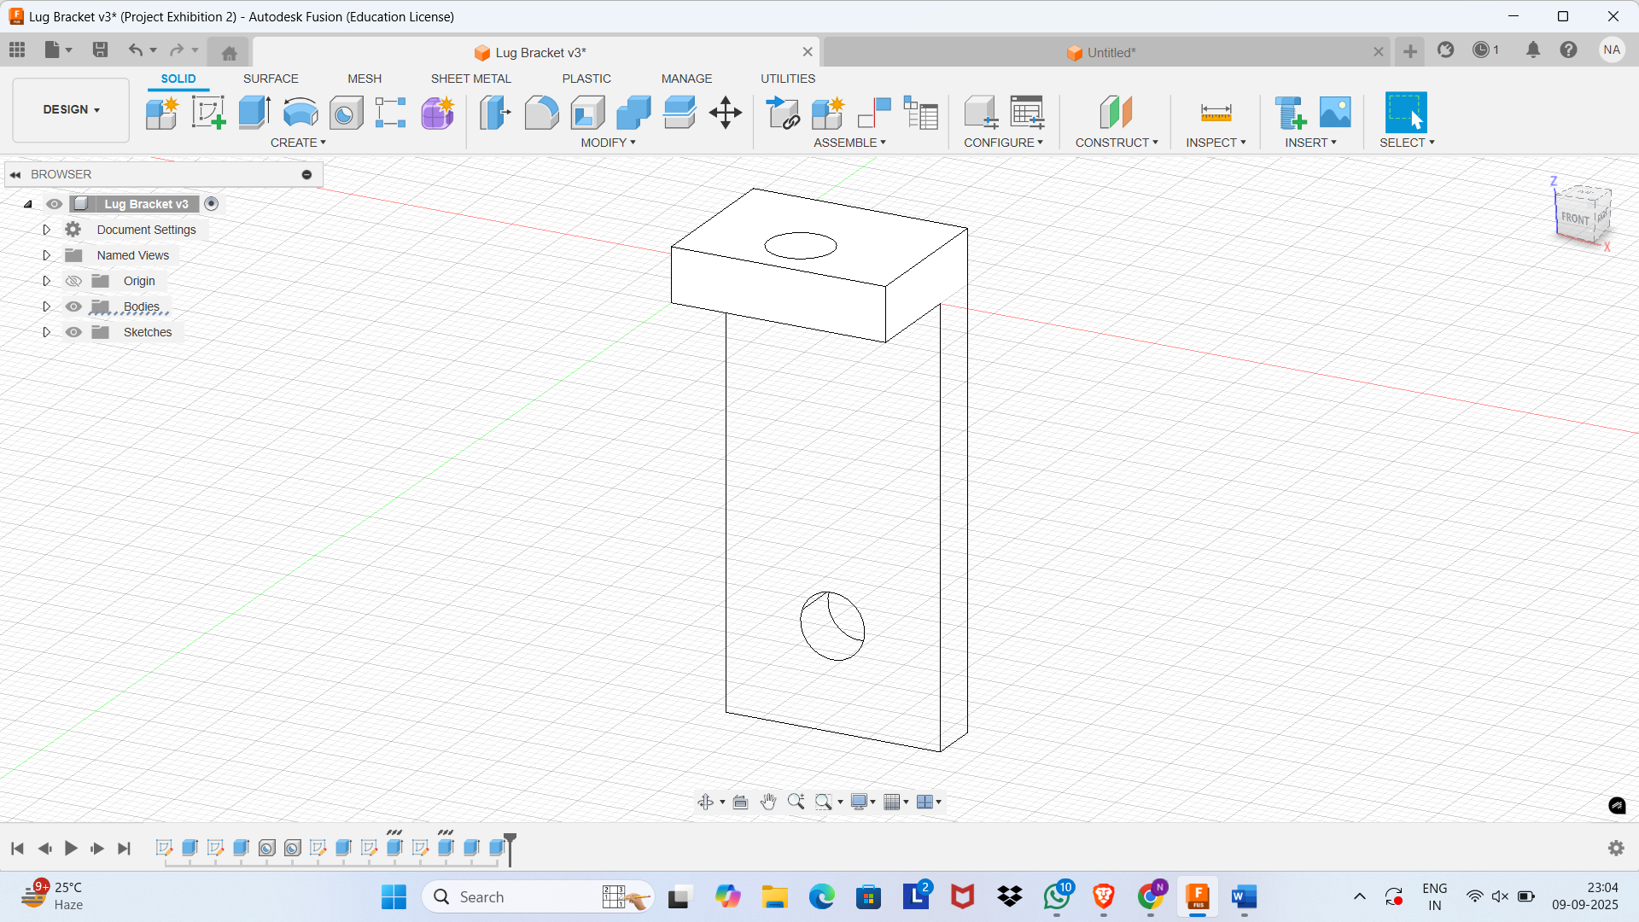

SIMULATION RESULTS

Simulations showed that the Lug Bracket we designed has a safety factor of 0.484, which is significantly less. Consequently, our bracket could not withstand stress and would break. Also, simulation results showcased that the region near the base hole and above it has the maximum stress. The reason behind this is that the force acting on the vertical plate is pulling it like a lever, which leads to prying of the base plate, but as the base hole acts as a pivot, this creates maximum tension in the region near and above the hole.

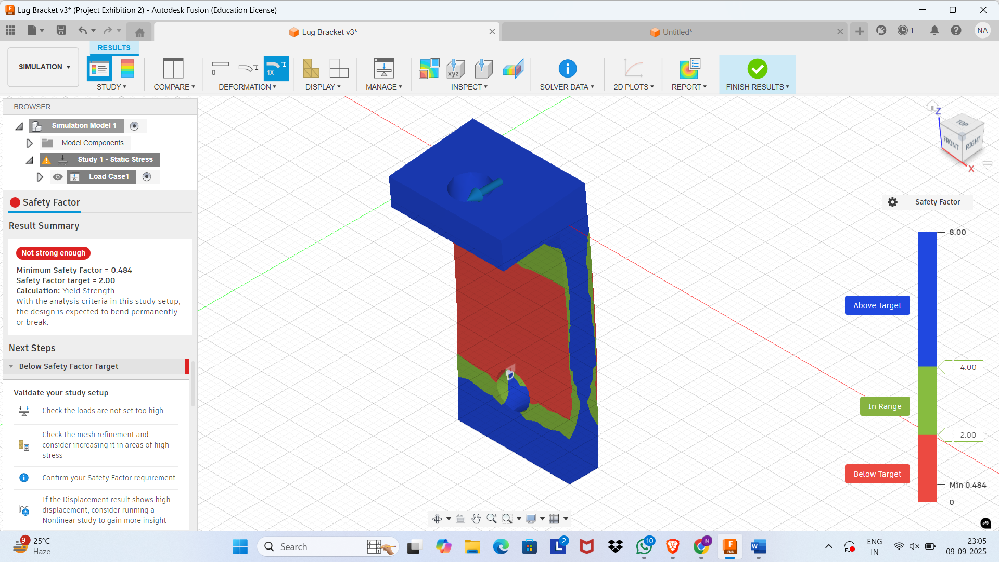

GENERATIVE SETUP

Now we know that the above design cannot withstand the high stress, so we use Generative Design to create all the possible designs. We preserved our whole T-shape and also avoided any changes in the position of the hole by making it an obstacle geometry.

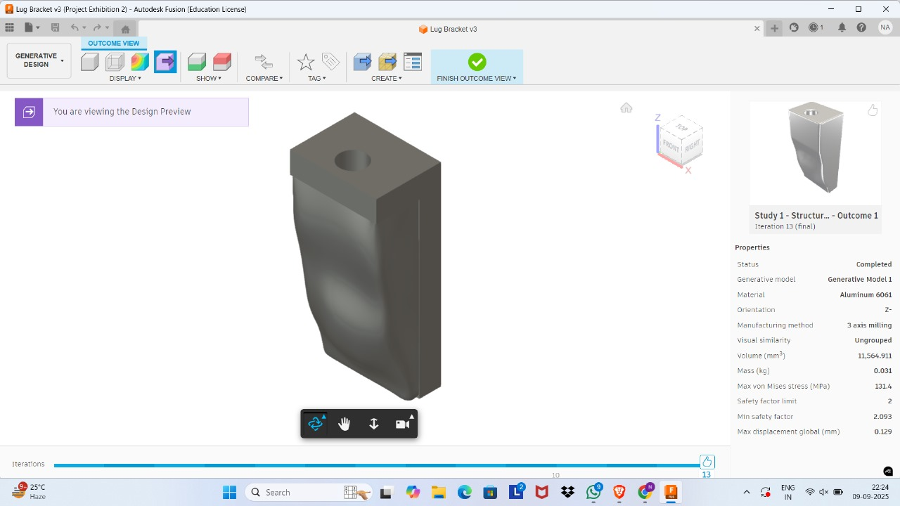

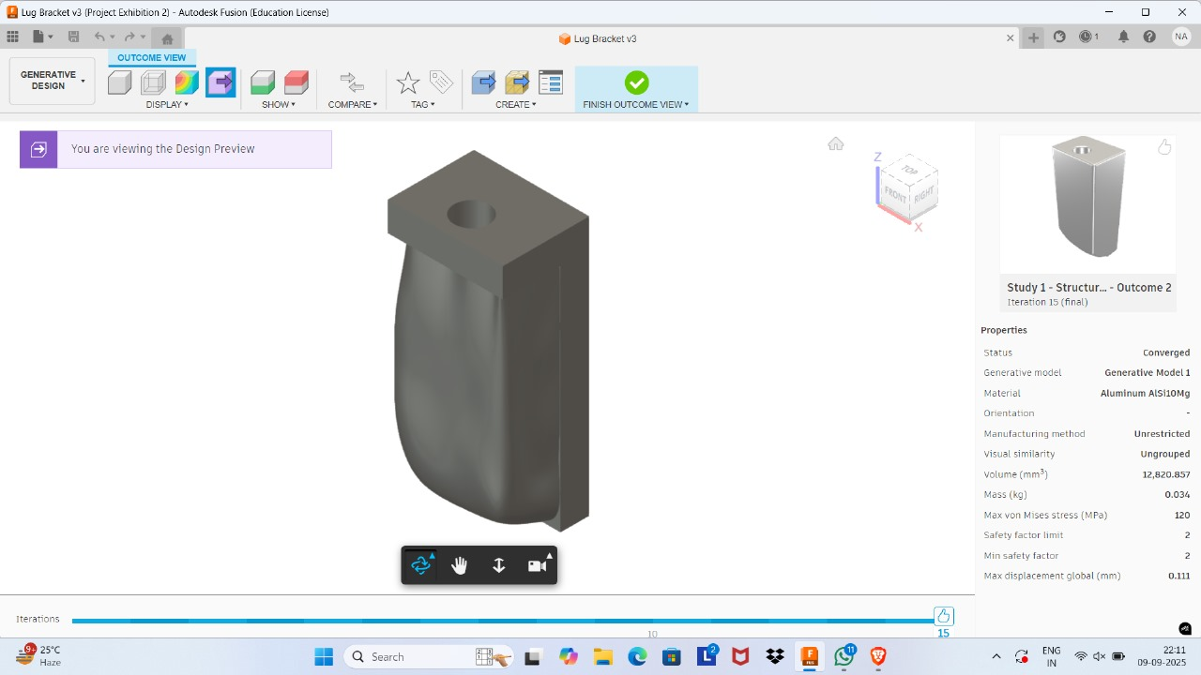

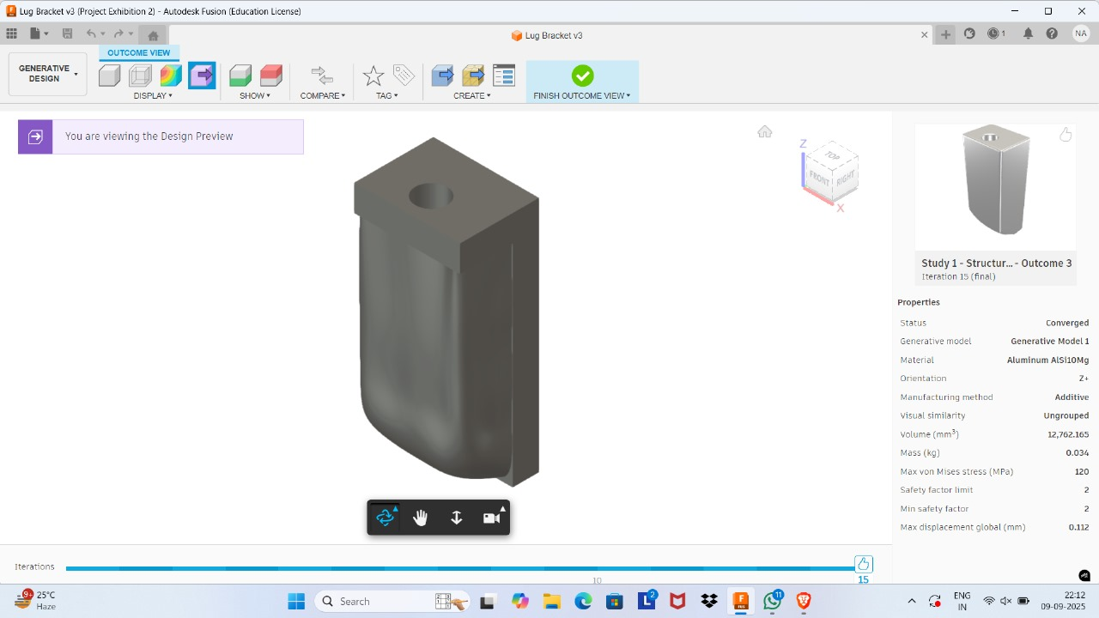

FINAL OUTCOMES

From Generative design, we got three outcomes. All the outcomes have a safety factor limit of 2. The first outcome has a mass of 0.031 kg and a minimum safety factor of 2.093; the other two designs have a mass of 0.034 kg and a minimum safety factor of 2.

|  |  |  |  |
| --- | --- | --- | --- |
| Outcome | Weight | Safety factor limit | Minimum safety factor |
| 1 | 0.031 kg | 2 | 2.093 |
| 2 | 0.034 kg | 2 | 2 |
| 3 | 0.034 kg | 2 | 2 |

CONCLUSION

From all the above outcomes, we conclude that the most lightweight and cost-effective design is of first outcome. This design has a safety factor greater than what is required, which will handle stress effectively, and also it has a lower weight compared to others, which will also decrease our production cost. Our final design is:

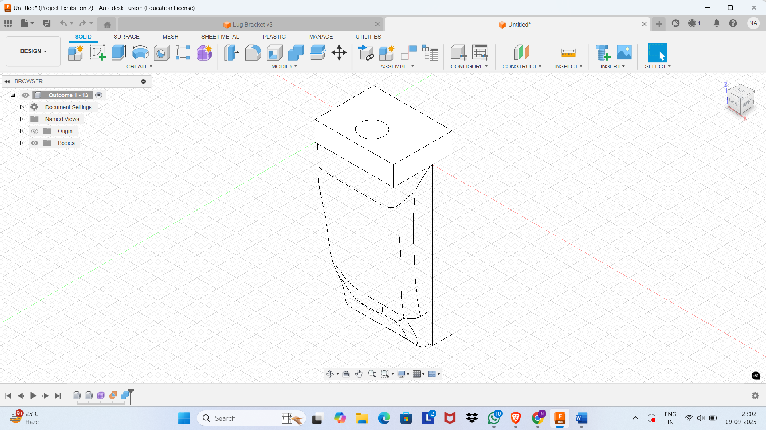

This process successfully converted a failed design into an optimized one, the one which is used in real life. It also helped us reduce the weight and the overall cost.

This design can be further manufactured by using some advance methods like DMLS and investment casting in the manufacturing industries.